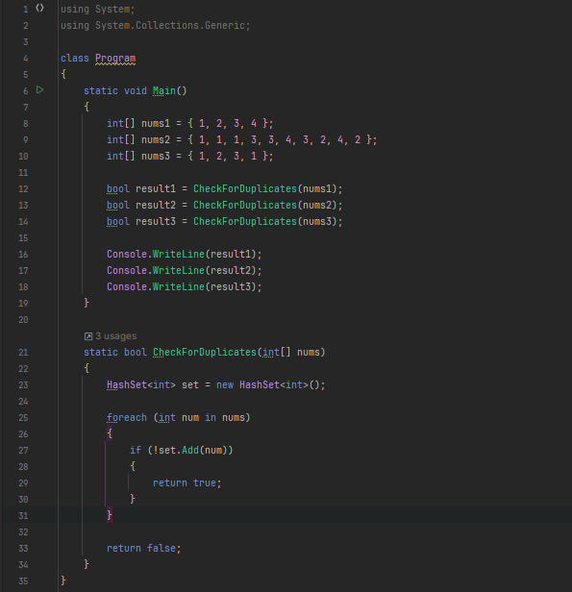

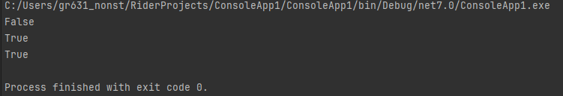

using System;  
using System.Collections.Generic;  
  
class Program  
{  
 static void Main()  
 {  
 int[] nums1 = { 1, 2, 3, 4 };   
 int[] nums2 = { 1, 1, 1, 3, 3, 4, 3, 2, 4, 2 };   
 int[] nums3 = { 1, 2, 3, 1 };   
  
 bool result1 = CheckForDuplicates(nums1);  
 bool result2 = CheckForDuplicates(nums2);  
 bool result3 = CheckForDuplicates(nums3);  
  
 Console.WriteLine(result1);  
 Console.WriteLine(result2);  
 Console.WriteLine(result3);  
 }  
  
 static bool CheckForDuplicates(int[] nums)  
 {  
 HashSet<int> set = new HashSet<int>();  
  
 foreach (int num in nums)  
 {  
 if (!set.Add(num))  
 {  
 return true;  
 }  
 }  
  
 return false;  
 }  
}